# **Results for the credit card approval project:** **Basic information:**

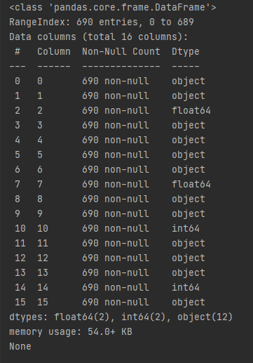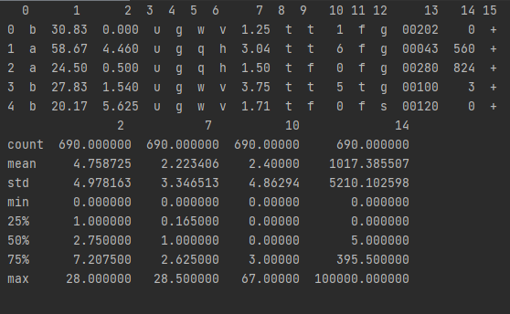

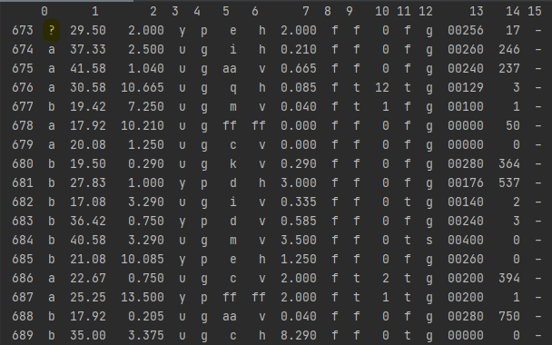**validate that the data is fully prepared for fitting:**  
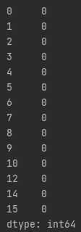types are correct and there are no nulls

**Basic scoring:  
**

This results show that our model approves too much,

**Final scoring:**

